Question 2: Networking Simulation
(Cisco Packet Tracer)

1.Project Context
As part of my internship as a Network Security Engineer Intern at a mid-sized financial service company expanding across Africa and Europe, I was tasked with designing and simulating a secure small enterprise network using Cisco packet Tracer. The objective was to build a realistic enterprise-level network simulation that incorporates proper network segmentation, secure inter-Vlan communication and controlled access to cloud resources.

The branch office consists of three key departments, each with distinct network requirements and access priviledges.

. Administrations (VLAN 10)- Handles Human Resources And Financial Operations.
This department deals with sensitive financial and personal data that requires strict access controls.

. Sales (VLAN 20)- Responsible For Customer Engagement And Business Growth.

. IT Support Department (VLAN 30)- Responsible For Managing Technical Infrastructure And Support.

Although employees are physically connected to the same switch, logical separation was achieved using VIRTUAL LOCAL AREA NETWORKS (VLANS) to improve security and performance.

2. Network Design and VLAN Segmentation

To begin, three VLANs were created on the switch, one for each department. VLANs logically segment the network, allowing each department to operate on a separate broadcast domain, thereby improving performance and security. Each VLAN was assigned a unique IP subnet.
The switch ports were configured in access mode and assigned to the corresponding VLANs. The Gigabitethernet0/0 interface was configured as a trunk port, allowing it to carry traffic for multiple VLANs to the router for inter-VLAN routing.

VLAN Configuration (Switch)
Switch> enable
Switch# configure terminal
Switch(config)# vlan 10
Switch(config-vlan)# name ADMIN
Switch(config-vlan)# exit
Switch(config)# vlan 20
Switch(config-vlan)# name SALES
Switch(config-vlan)# exit
Switch(config)# vlan 30
Switch(config-vlan)# name IT
Switch(config-vlan)# exit
Switch(config)# interface fastEthernet0/1
Switch(config-if)# switchport mode access
Switch(config-if)# switchport access vlan 10
Switch(config-if)# exit
Switch(config)# interface fastEthernet0/2
Switch(config-if)# switchport mode access
Switch(config-if)# switchport access vlan 20
Switch(config-if)# exit
Switch(config)# interface fastEthernet0/3
Switch(config-if)# switchport mode access
Switch(config-if)# switchport access vlan 30
Switch(config-if)# exit
Switch(config)# interface gigabitEthernet0/0
Switch(config-if)# switchport mode trunk allowed vlan 10,20,30
Switch(config-if)# exit
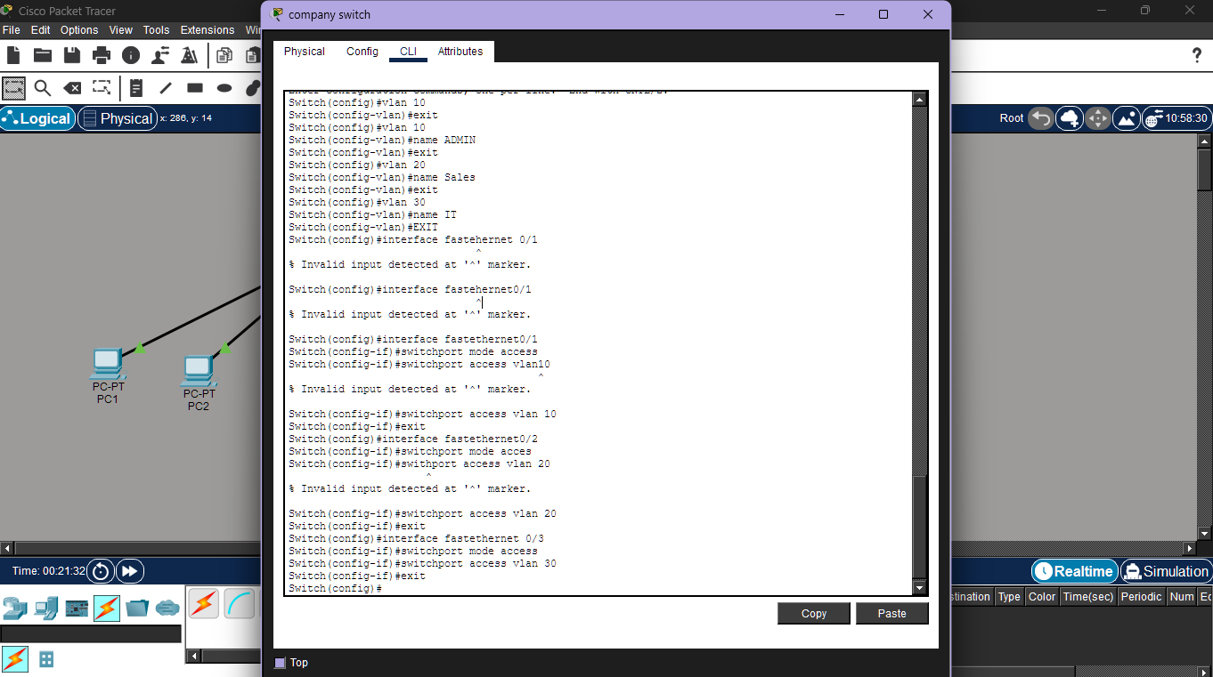

3. Inter-Vlan Routing (Router -on-a-Stick configuration)
Since Layer 2 switches cannot perform routing between VLANs, I implemented
Router-on-a-Stick (ROAS) on the router. This method uses a single physical router
interface divided into multiple subinterfaces, each corresponding to a VLAN. Each
subinterface is configured with an IP address to serve as the default gateway for the
devices within that VLAN.

This configuration enables controlled inter-VLAN communication, ensuring that traffic passes
through the router where security policies (ACLs) can be enforced.
Router Configuration (ROAS)
Router> enable
Router# configure terminal
Router(config)# interface gigabitEthernet0/0.10
Router(config-subif)# encapsulation dot1Q 10
Router(config-subif)# ip address 192.168.10.1 255.255.255.0
Router(config-subif)# exit
Router(config)# interface gigabitEthernet0/0.20
Router(config-subif)# encapsulation dot1Q 20
Router(config-subif)# ip address 192.168.20.1 255.255.255.0
Router(config-subif)# exit
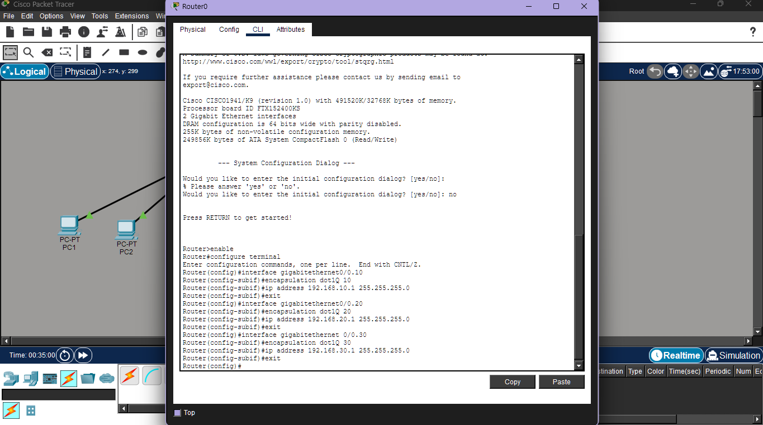

4. Basic ACLs (Access Control List)
The network was simulated to demonstrate secure VLAN segmentation and controlled access to cloud resources. Admin VLAN users were able to access the cloud payroll system, while sales VLAN users were restricted from Admin resources and permitted access only to IT support. Access Control Lists were used to enforce security policies, ensuring protection of sensitive financial systems and secure inter-VLAN communication.
ACL Configuration
Router#configure terminal
Enter configuration commands, one per line. End with CNTL/Z.
Router(config)#no ip access-list extended sales-restriction
Router(config)#ip access-list extended sales-restriction
Router(config-ext-nacl)#deny ip 192.168.20.0 0.0.0.255 192.168.10.0 0.0.0.255
Router(config-ext-nacl)#permit ip any any
Router(config-ext-nacl)#exit
Router(config)#interface gigabitethernet 0/0.20
Router(config-subif)#ip access-group sales-restriction out
Router(config-subif)#end
Router#
%SYS-5-CONFIG_I: Configured from console by console

Router#write memory
Building configuration...
[OK]
Router# show access-list
Extended IP access list sales-restriction
10 deny ip 192.168.20.0 0.0.0.255 192.168.10.0 0.0.0.255
20 permit ip any any
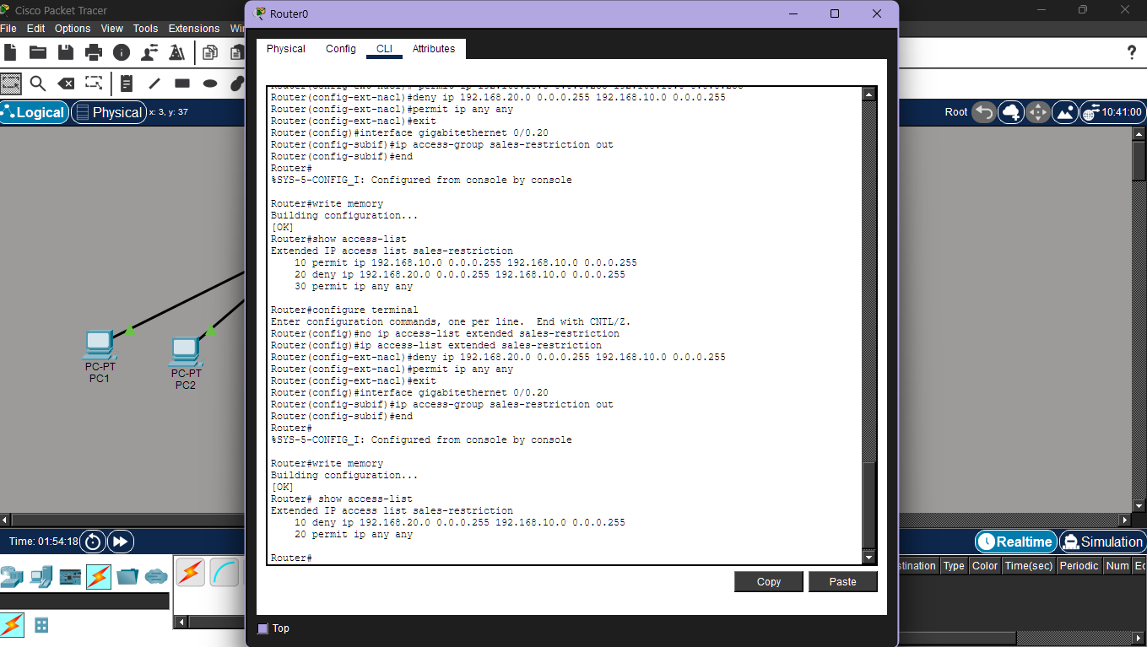

5. Security Risk of not separating department
If all employees are on the same network (no VLANs), the main risks are:
- Unauthorized access: Sales staff could access Admin systems (HR, payroll, finance).
- Data leakage: Sensitive financial or employee data could be viewed or copied.
- Malware spread: A compromised Sales PC could infect Admin and IT systems.
- Lack of control: No way to enforce different security policies per department.
- Compliance issues: Financial services companies must enforce least-privilege access.
6. Configuring access ports for each VLAN
Access ports are switch ports where end devices are plugged in.
Lets use port 1-8 for admins, ports 9-16 for sales and ports 17-24 for IT support.
Configuration Steps
Switch>enable
Switch#configure terminal
Enter configuration commands, one per line. End with CNTL/Z.
Switch(config)#interface range fastethernet 0/1-8
Switch(config-if-range)#switchport mode access
Switch(config-if-range)#switchport access vlan 10
Switch(config-if-range)#exit
Switch(config)#interface range fastethernet 0/9-16
Switch(config-if-range)#switchport mode access
Switch(config-if-range)#switchport access vlan 20
Switch(config-if-range)#exit
Switch(config)#interface range fastethernet0/17-24
Switch(config-if-range)#switchport mode access
Switch(config-if-range)#switchport access vlan 30
Switch(config-if-range)#exit
Switch(config)#
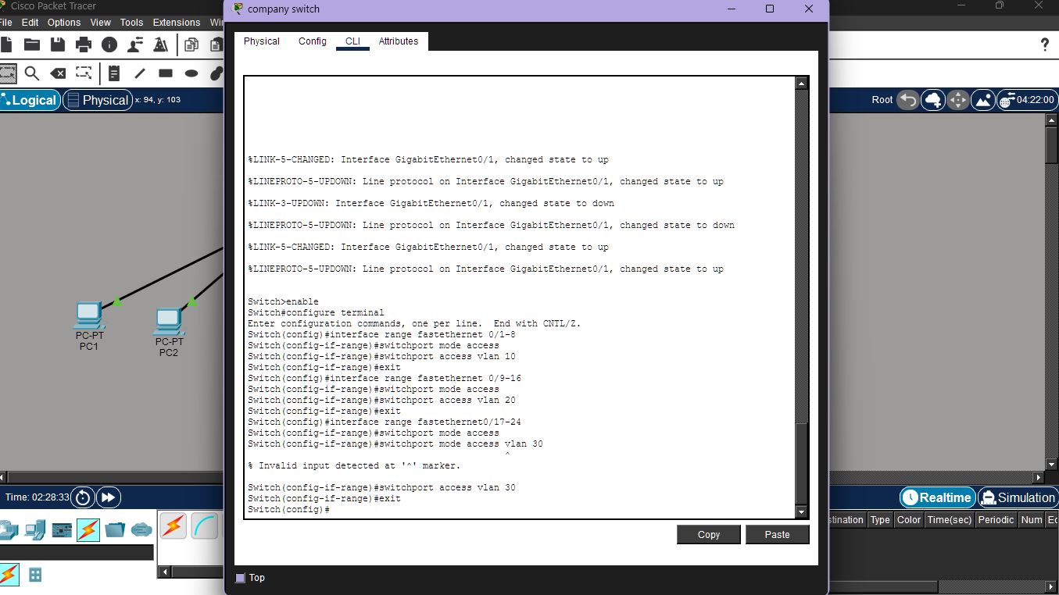

7.Purpose of trunk ports in this scenario
Trunk ports are used to carry multiple VLANs over one physical link.
Why trunks are needed:
- They are needed to allows Admin, Sales, and IT VLAN traffic to travel between devices
- VLAN tags identify which traffic belongs to which VLAN
- Enables inter-VLAN routing while keeping departments logically separated

QUESTION 2: Inter-VLAN Communication

How inter-VLAN routing works
In this project, I used inter-VLAN routing to allow communication between different VLANs. Each VLAN represents a separate department and is treated as its own network. By default, devices in different VLANs cannot communicate with each other. To enable controlled communication, I configured a router to route traffic between the VLANs. All devices send traffic to the router as their default gateway, which then forwards the traffic to the appropriate VLAN.

Where inter-VLAN routing is configured
I configured inter-VLAN routing on a router using sub-interfaces. This method is suitable for a small enterprise network and works well in Cisco Packet Tracer.

Rule to allow Admin but restrict Sales
In my network, I allowed the Admin VLAN to access the cloud payroll system because it handles sensitive financial data. I restricted the Sales VLAN from accessing Admin resources, while still allowing Sales to communicate with the IT Support VLAN. This helps protect sensitive systems while supporting business operations.
(Access Control Lists ACLs)

What an ACL is and why it is important
An Access Control List (ACL) is a set of rules that I used to control network traffic. ACLs are important because they help prevent unauthorized access, protect sensitive financial systems, and enforce department-based security policies.

Simple ACL logic used in this project
In this project, I implemented the following ACL logic:
- I allowed the IT VLAN full access to all VLANs and cloud resources
- I allowed the Admin VLAN access to cloud services
- I denied the Sales VLAN access to Admin VLAN resources
- I allowed the Sales VLAN access to the IT Support VLAN

Where the ACL is applied
I applied the ACL on the router interface connected to the VLANs, so that unauthorized traffic is blocked before it reaches sensitive systems.
Conclusion

In this project, I designed a small enterprise network using VLANs to separate departments and improve security. Inter-VLAN routing was configured to allow controlled communication between departments, while Access Control Lists (ACLs) were used to restrict unauthorized access to sensitive systems. This design ensures secure network segmentation, protects financial data, and allows only approved access to cloud resources. Overall, the network meets the company’s security and operational requirements.
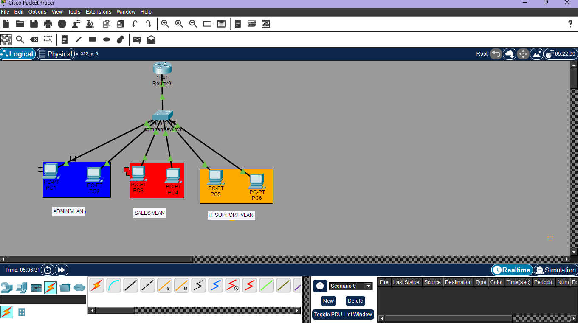
Final network topology diagram in Cisco Packet Tracer.

